Business Question and Visualization Report
Date | 12 August 2026
Team ID
Project Name | India’s Agricultural Crop Production Analysis
Maximum Marks | 5 Marks

Business Question and Visualization
- Which states have the highest agricultural production?
- Visualization: Map visualization showing state-wise agricultural production.
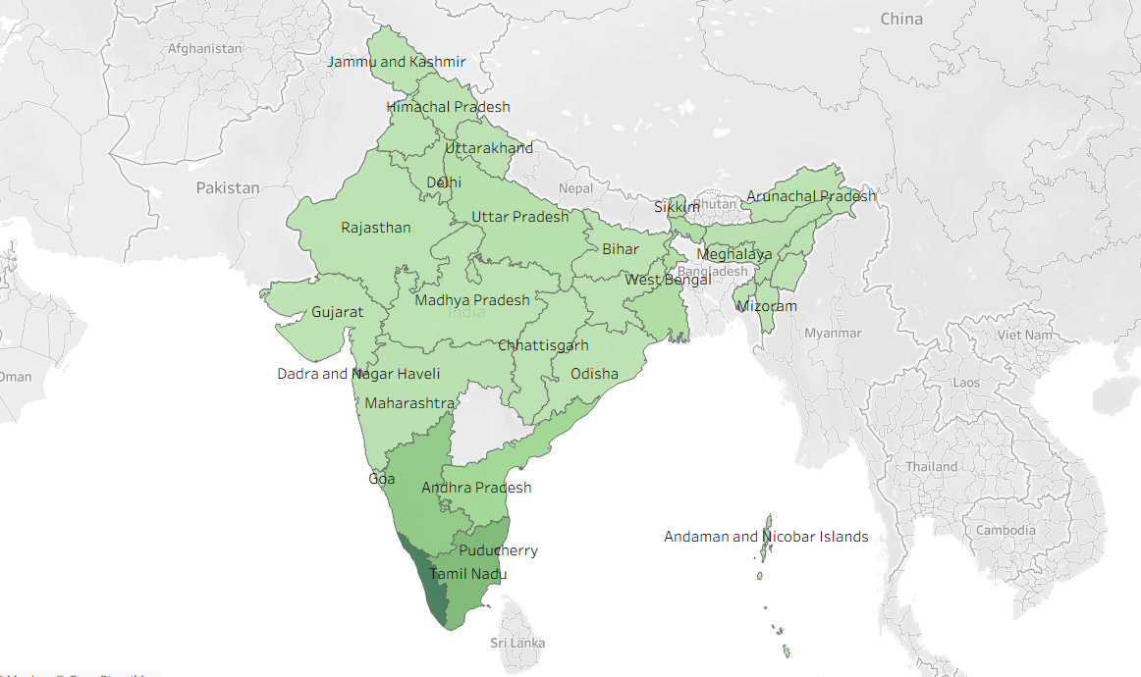

- Which states have the largest cultivated area?
- Visualization; Bar chart showing state-wise cultivated area.
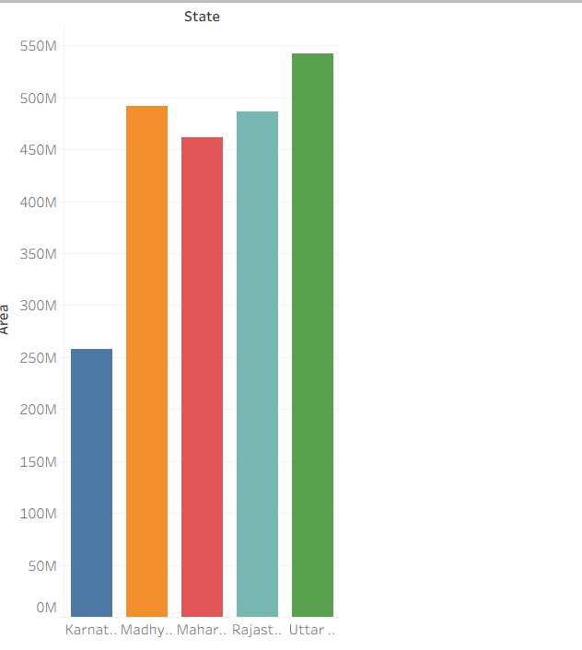

- How does Agricultural production change over the years?
Visualization: Bar chart showing total production by year.

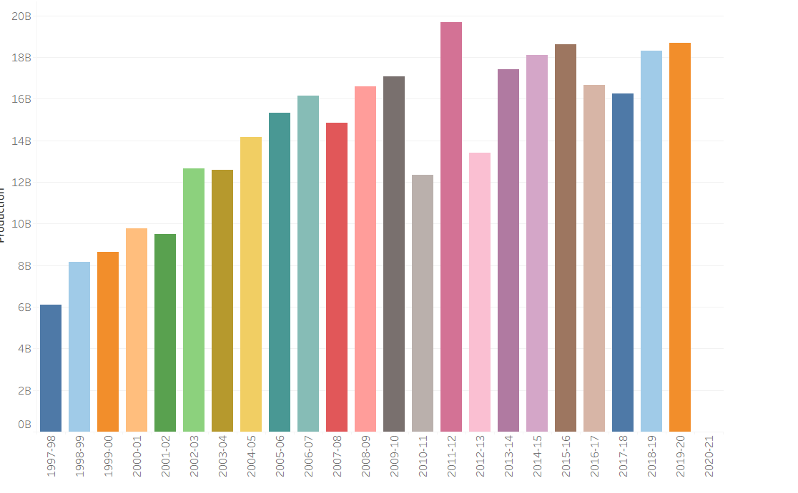
- Which crops occupy the largest cultivated area?
- Visualization: Bar chart comparing area for different crops.

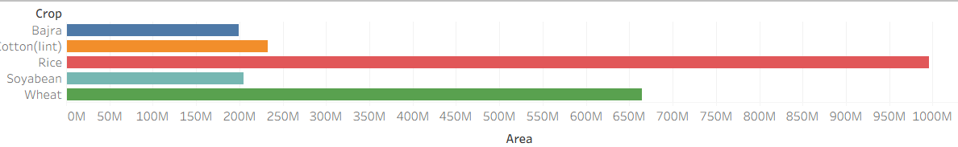

- Which state contribute the most to agricultural production?
- Visualization: Bar chart showing production by state.

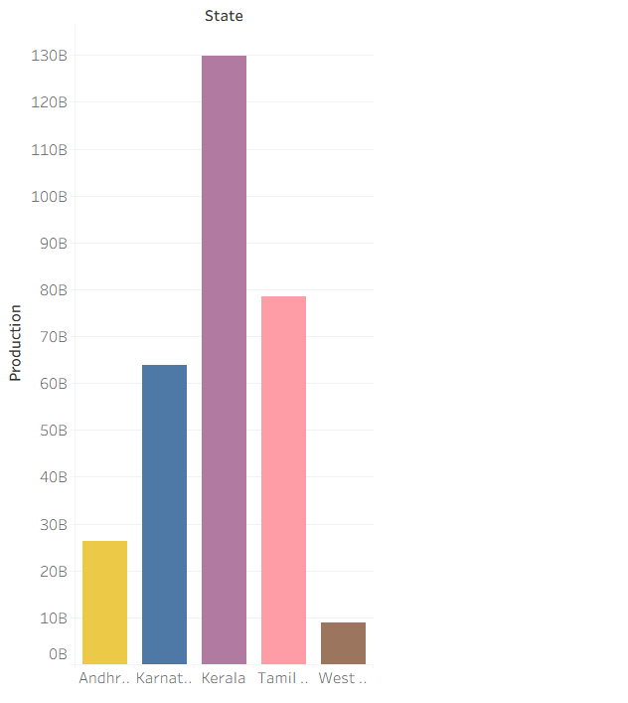
- How does crop production vary between different seasons?

- Visualization: Pie chart comparing production across season.

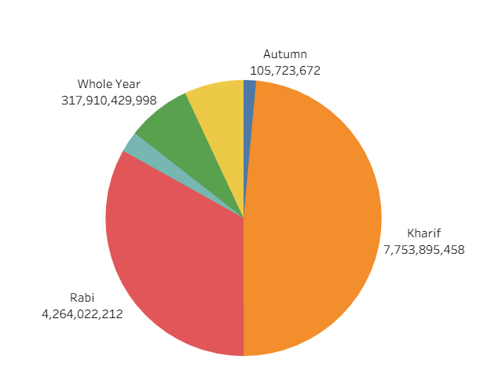

- How has agricultural yield changed over the years?
- Visualization: Line chart showing year-wise agricultural yield trend
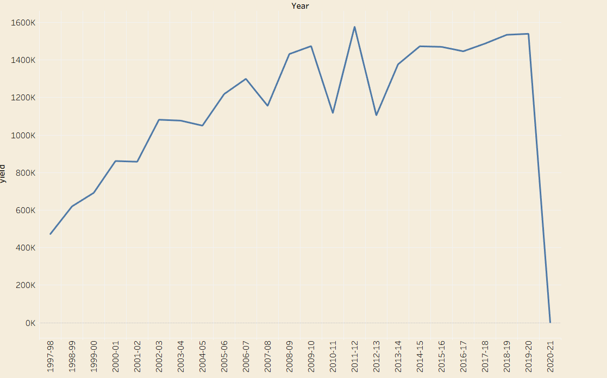
- How is agricultural production distributed across different unit types?
- Visualization: Donut chart showing production distribution by unit type.
